

A report of the conducted Mini Project on the topic of

“**Food Delivery Website”**

Being submitted to the Department of Computer Science Engineering Department, MVJ College of Engineering in the academic year 2022- 23

Submitted by the joint collaboration of:

* **Shashank M (1MJ20CS200)**
* **Soumalya Ghosh (1MJ20CS208)**
* **Tushar Das (1MJ20CS224)**
* **Vimal Karthik L V (1MJ20CS237)**

From the 5th Semester ‘D’ Section

Under the Guidance of:

**Ms. Navya and Ms.Anusha.s**

**Assistant Professor**,

**Department of Computer Science and Engineering**



# Certificate

This is to certify that the mini project titled “Food Delivery Website” is a bona fide collaborative work done by Shashank M(1MJ20CS200), Soumalya Ghosh(1MJ20CS208), Tushar Das (1MJ20CS224), and Vimal Karthik L V(1MJ20CS237) all bona fide students of the MVJ College of Engineering. This mini project is given by the collaboration of the four of the above students for the partial fulfillment of the successful clearance of the 5th semester in the department of Computer Science and Engineering at MVJ College of Engineering for the year 2022-23. It is certified that the corrections/suggestions that were indicated at the assessments have been incorporated in the project and the report. This mini project report has been approved

**Signature of the Guides**

**Signature of the HOD**

# Abstract

# Online food delivery is a convenient and easy way for customers to order and receive meals from their favorite restaurants without having to leave their homes. Customers can browse menus, place orders, and make payments through a website or app, and the food is delivered directly to their doorstep. This service is particularly popular during the COVID-19 pandemic, as it allows people to continue enjoying restaurant-quality food while practicing social distancing. Online food delivery offers a range of benefits for both customers and restaurants, including increased efficiency and revenue.

**Acknowledgement**

The satisfaction and euphoria that accompany the successful completion of any task would be incomplete without the mention of the people who made it possible, whose constant guidance and encouragement crowned our effort with success.

First and foremost, we would like to express our thanks to MVJ College of Engineering for delivering us students a platform to create and display our creations in any field, making it wonderful experiences for us to shape up our careers.

We express our sincere gratitude to our Principal **Dr. P Mahabaleshwarappa**, & Vice Principal **Mrs**. **M Brindha**, MVJ College of Engineering for providing facilities.

We wish to place on record our grateful thanks to Professor, **Dr. Sudhan,** Head Of the Department, Computer Science and Engineering, MVJ College of Engineering, Bangalore for providing encouragement and guidance for the tenure of the project.

We consider it a privilege and honor to express our sincere gratitude to the group’s guides **Ms. Navya** and **Ms. Anusha S**, Department of Computer Science & Engineering for their valuable guidance throughout the tenure of this mini project and whose support and encouragement made this work possible.

I wish to thank the faculty of Computer Science and Engineering department whose suggestions and constructive criticisms have enabled us to surpass many of the hurdles along the way.

Last but not the least, we would have to thank all our friends and family whose support was indispensable throughout the duration of the project and beyond.

Thank You.

## LIST OF TABLES

Biriyani

|  |  |  |  |
| --- | --- | --- | --- |
| Id | Name | Price | Rating |
| 1 | Ambur -Chicken -Biriyani | 200 | 4.3 |
| 2 | Hydrabadi-Chicken-Biriyani | 230 | 4.3 |
| 3 | Goan-Fish-Biriyani | 250 | 4.3 |
| 4 | Egg-Biriyani | 140 | 4.3 |
| 5 | Hydrabadi Mutton Biriyani | 270 | 4.3 |
| 6 | Kamrupi Biriyani | 220 | 4.3 |
| 7 | KashmiriPulav | 170 | 4.3 |
| 8 | Mughalai Biriyani | 250 | 4.3 |

Chicken

|  |  |  |  |
| --- | --- | --- | --- |
| Id | Name | Price | Rating |
| 1 | Chicken-Roast | 140 | 4.3 |
| 2 | Chicken-Curry | 160 | 4.3 |
| 3 | Chicken-do-Pyaza | 170 | 4.3 |
| 4 | Chicken-Masala | 150 | 4.3 |
| 5 | Button-Chicken | 180 | 4.3 |
| 6 | Chicken-Kebab | 170 | 4.3 |
| 7 | Chicken-Tikka-Masala | 190 | 4.3 |
| 8 | Chicken-Kalmi-Kabab | 160 | 4.3 |

Chinese

|  |  |  |  |
| --- | --- | --- | --- |
| Id | Name | Price | Rating |
| 1 | Veg-Momos | 60 | 4.3 |
| 2 | Chicken-Manchurian | 140 | 4.3 |
| 3 | Chilli-Chicken | 130 | 4.3 |
| 4 | Chowmein-Veg | 70 | 4.3 |
| 5 | Chowmein-Chicken | 100 | 4.3 |
| 6 | Spring-rolls | 80 | 4.3 |
| 7 | Szechuan-Chicken | 120 | 4.3 |
| 8 | Veg-Fried-Rice | 90 | 4.3 |

Veg_Curry

|  |  |  |  |
| --- | --- | --- | --- |
| Id | Name | Price | Rating |
| 11 | Navaratna-Korma | 110 | 4.3 |
| 21 | VEG-Jal-Frezi | 145 | 4.3 |
| 31 | VEG-Briyani | 200 | 4.3 |
| 41 | Vegetable-Curry | 185 | 4.3 |
| 51 | Vegetabl-Kolhapuri | 300 | 4.3 |
| 61 | Vegetable-Masala | 250 | 4.3 |
| 71 | Vegetable-Pakora | 220 | 4.3 |

Paneer_curry

|  |  |  |  |
| --- | --- | --- | --- |
| id | Name | Price | Rating |
| 10 | Matar-Paneer | 285 | 4.3 |
| 20 | Palak_Paneer | 250 | 4.3 |
| 30 | Paneer_Butter_Masala | 280 | 4.3 |
| 40 | Paneer_Do_Pyaza | 200 | 4.3 |
| 50 | Paneer_Hydrabadi | 255 | 4.3 |
| 60 | Paneer_Lababdar | 265 | 4.3 |
| 70 | Shahi_Paneer | 285 | 4.3 |
| 80 | Vegetable_Curry | 224 | 4.3 |

South_Indian

|  |  |  |  |
| --- | --- | --- | --- |
| id | Name | Price | Rating |
| 1 | Butter_Masala_Dosa | 70 | 4.3 |
| 2 | Idli_with_rice_flour | 40 | 4.3 |
| 3 | Masala_Dosa | 60 | 4.3 |
| 4 | Mysore_Bonda | 30 | 4.3 |
| 5 | Onion_Uttapam | 60 | 4.3 |
| 6 | Plain_Dosa | 50 | 4.3 |
| 7 | Rava_Uttapam | 50 | 4.3 |
| 8 | Sambar_Vada | 35 | 4.3 |

## TABLE OF CONTENTS

1. INTRODUCTION 1
2. SYSTEM REQUIREMENTS 2

2.1 Hardware Requirements..........................................................................

2.2 Software Requirements .............................................................................

1. PROBLEM DESCRIPTION 3
2. SYSTEM DESIGN *4*

4.1 ER Diagram.....................................................................................................

4.2 schema Diagram ...........................................................................................

**5. Implementation** ..............................................................................................................

5.1 Introduction.....................................................................................................

5.2 Source code......................................................................................................

**6. Screenshots** ...........................................................................................................................

**7. Conclusion and Future Scope** ..............................................................................

Part 1

# Introduction

We know that online food delivery is the norm in recent times as the customers can order from the comfort of their homes or workplaces and there is not a need to specially allocate time to cook and it might cut into important time allotments.

This kind of a food/meal delivery service is possible in today’s lifestyle as online payment/net banking has been highly promoted in recent times and almost every part of our subcontinent uses these methods of payment as compared to the traditional exchange of money. It has become more convenient to pay using the ‘UPI’ payment as you don’t have to carry stacks of money everywhere or search for particular amount of change anywhere else.

In light of the rapidly transforming society towards the food delivering services, our group will be making a food delivery website as a mini project to try to understand the nuances behind it as well as to explore what can possibly be the adversities while making this kind of a website and the possible solutions to these problems which in turn will help us to get a possible understanding towards the thought process that goes into making similar kinds of websites.

This project is based on the creation of a food website which :

* Is based on the current design of food creation websites
* Ease in browsing and choosing food items
* Convenient to use with an interactive website.

Part 2

# System Requirements

### Hardware Requirements:

* + - **Operating System:** Windows 11
    - **Processor:** INTEL i5 or ANY
    - **Memory:** 2 GB minimum, 4 GB recommended
    - **Screen resolution:** 1280*1024 or larger
    - **Application Window Size:** 1024*680 or larger
    - **Internet Connection:** Not required

### Software Requirements

* + - **Client:** Operating System(preferably Windows)
    - **Web Server:** Apache HTTP server
    - **Database:** MySQL DB, Express JS
    - **Language:** HTML,CSS, JAVASCRIPT, Bootstrap

Part 3

# Problem Description

The online food ordering system sets up a food menu on a website and the customers can easily place the order according to their dietary needs. This allows customers to easily track their orders as well. The management of the website maintains a database for customers which help improve their delivery service and well as maintain previous orders for the customer to view.

The website also contains a feedback system where the experience while using the website or the food quality is rated. Each user gets their own User ID and password to log in and it is compulsory to do so to order the dishes.

We have made sure that the user experience is as pleasant as possible without much concern or room for any major inconveniences. The website is designed for the user to seamlessly access our website and conveniently order from them without much effort needed.

We can assure that this website can be used at any time with ease for any customer.

Part 4

# System Design

* 1. *Entity-Relationship (ER) Diagram*

*4.2)Schema Diagram*

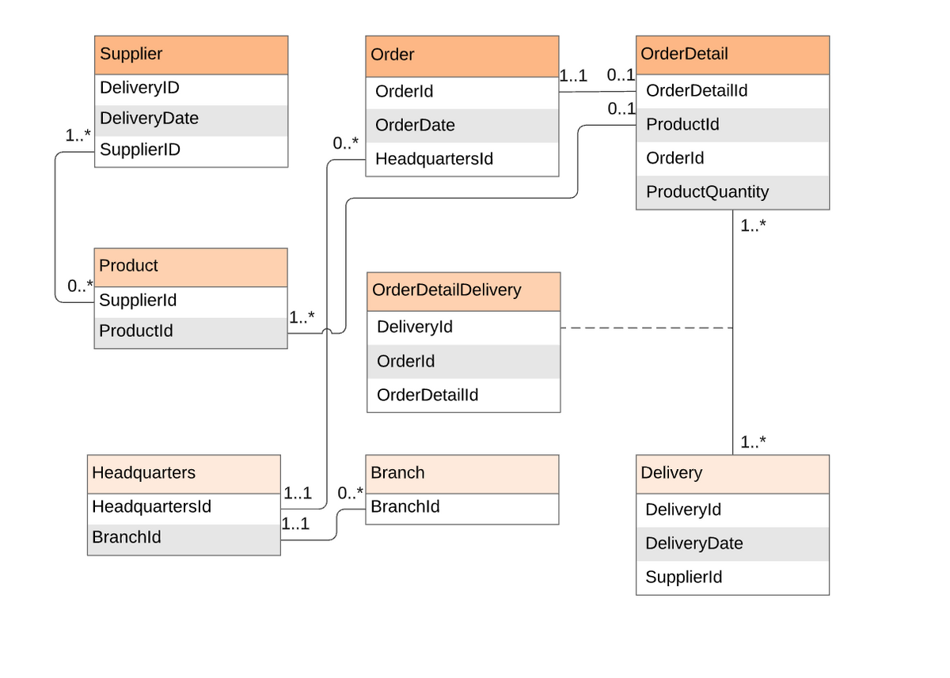

Part 5

**Implementation**

*5.1)Introduction*

Online food delivery is a service that allows customers to order and receive meals from restaurants through the internet. Customers can browse menus, place orders, and make payments through a website or app, and the food is delivered directly to their doorstep. This service is provided by a variety of companies, including food delivery apps, websites, and telephone or fax-based ordering systems. Online food delivery is a convenient option for people who want to enjoy restaurant-quality meals without having to leave their homes, and it is also a useful service for busy individuals who do not have the time to cook or go out to eat. In recent years, online food delivery has become increasingly popular, and many restaurants now offer this service as a way to reach a wider customer base and boost sales. The COVID-19 pandemic has also led to a surge in online food delivery, as people have turned to this service to reduce their risk of exposure to the virus by ordering food for home delivery or pickup.

*5.2)Source Code*

**Online food.html**

**<!DOCTYPE html>**

**<html lang="en">**

**<head>**

**<meta charset="UTF-8">**

**<meta http-equiv="X-UA-Compatible" content="IE=edge">**

**<meta name="viewport" content="width=device-width, initial-scale=1.0,viewport-fit=cover">**

**<title>Food Website</title>**

**<link rel="stylesheet" href="./css/online.css">**

**<!-- <script src="./js/fooditem.js"></script> -->**

**<script src="./js/index.js"></script>**

**<!--link rel="stylesheet" href="./js/fooditem.js">**

**<link rel="stylesheet" href="./js/index.js"-->**

**<link rel="stylesheet" href="https://cdnjs.cloudflare.com/ajax/libs/font-awesome/4.7.0/css/font-awesome.min.css">**

**</head>**

**<body>**

**<!-- desktop view -->**

**<div class="container" id="container">**

**<div id="menu">**

**<div class="title">**

**<img src="./images/foodie hunter.png" alt="">**

**</div>**

**<div class="menu-item">**

**<a href="/about">About</a>**

**<a href="#">Services</a>**

**<a href="#">Your Orders</a>**

**<a href="#">Wishlists</a>**

**<a href="#">Cart</a>**

**<a href="/contact">Contact</a>**

**<a href="/payment">Checkout</a>**

**</div>**

**</div>**

**<div id="food-container">**

**<div id="header">**

**<div class="add-box">**

**<i class="fa fa-map-marker your-address" id="add-address"> Your Address</i>**

**</div>**

**<div class="util">**

**<i class="fa fa-search"> Search</i>**

**<i class="fa fa-tags"> Offers</i>**

**<i class="fa fa-cart-plus" id="cart-plus"> 0 Items</i>**

**</div>**

**</div>**

**<div id="food-items" class="d-food-items">**

**<div id="biryani" class="d-biryani">**

**<p id="category-name">Biryani</p>**

**</div>**

**<div id="chicken" class="d-chicken">**

**<p id="category-name">Chicken Delicious</p>**

**</div>**

**<div id="paneer" class="d-paneer">**

**<p id="category-name">Paneer Mania</p>**

**</div>**

**<div id="vegetable" class="d-vegetable">**

**<p id="category-name">Pure Veg Dishes</p>**

**</div>**

**<!--div id="chinese" class="d-chinese">**

**<p id="category-name">Chinese Corner</p>**

**</div-->**

**<div id="south-indian" class="d-south-indian">**

**<p id="category-name">South Indian</p>**

**</div>**

**</div>**

**<div id="cart-page" class="cart-toggle">**

**<p id="cart-title">Cart Items</p>**

**<p id="m-total-amount">Total Amout : 100</p>**

**<table>**

**<thead>**

**<td>Item</td>**

**<td>Name</td>**

**<td>Quantity</td>**

**<td>Price</td>**

**</thead>**

**<tbody id="table-body">**

**</tbody>**

**</table>**

**<div class="btn-box">**

**<button class="cart-btn" onClick="window.location.href = '/payment'">Checkout</button>**

**</div>**

**</div>**

**</div>**

**<div id="cart">**

**<div class="taste-header">**

**<div class="user">**

**<i class="fa fa-user-circle" id="circle"> Account</i>**

**</div>**

**</div>**

**<div id="category-list">**

**<p class="item-menu">Go For Hunt</p>**

**<div class="border"></div>**

**</div>**

**<div id="checkout" class="cart-toggle">**

**<p id="total-item">Total Item : 5</p>**

**<p id="total-price"></p>**

**<p id="delievery">Free delievery on $ 40</p>**

**<button class="cart-btn" onClick="window.location.href = '/payment'">Checkout</button>**

**</div>**

**</div>**

**</div>**

**<!-- mobile view -->**

**<div id="mobile-view" class="mobile-view">**

**<div class="mobile-top">**

**<div class="logo-box">**

**<img src="/images/foodielogo.png" alt="" id="logo">**

**<i class="fa fa-map-marker your-address" id="m-add-address"> Your Address</i>**

**</div>**

**<div class="top-menu">**

**<i class="fa fa-search"></i>**

**<i class="fa fa-tag"></i>**

**<i class="fa fa-heart-o"></i>**

**<i class="fa fa-cart-plus" id="m-cart-plus"> 0</i>**

**</div>**

**</div>**

**<div class="item-container">**

**<div class="category-header" id="category-header">**

**</div>**

**<div id="food-items" class="food-items">**

**<div id="biryani" class="m-biryani">**

**<p id="category-name">Biryani</p>**

**</div>**

**<div id="chicken" class="m-chicken">**

**<p id="category-name">Chicken Delicious</p>**

**</div>**

**<div id="paneer" class="m-paneer">**

**<p id="category-name">Paneer Mania</p>**

**</div>**

**<div id="vegetable" class="m-vegetable">**

**<p id="category-name">Pure Veg Dishes</p>**

**</div>**

**<div id="chinese" class="m-chinese">**

**<p id="category-name">Chinese Corner</p>**

**</div>**

**<div id="south-indian" class="m-south-indian">**

**<p id="category-name">South Indian</p>**

**</div>**

**</div>**

**</div>**

**<div class="mobile-footer">**

**<p>Home</p>**

**<p>Cart</p>**

**<p>offers</p>**

**<p>orders</p>**

**</div>**

**</div>**

**</body>**

**</html>**

**Register.html**

**<html>**

**<head>**

**<title>Food Hunter Resgistration</title>**

**<style>**

**.truck{**

**position:absolute;**

**width:250px;**

**top:20px;**

**right:50px;**

**}**

**body{**

**background-image: linear-gradient(to right, rgb(131, 131, 24) , rgb(208, 151, 60));**

**}**

**ul {list-style-type:none;}**

**#heading{**

**text-decoration:underline;**

**font-style: italic;**

**color:black;**

**text-align:center;**

**}**

**#para{**

**font-size:20px;**

**font-style: italic;**

**color:blue;**

**text-align:center;**

**}**

**</style>**

**</head>**

**<body>**

**<script>**

**function validate()**

**{**

**let N=document.getElementById("Name");**

**let E=document.getElementById("email");**

**let P=document.getElementById("phone");**

**let A=document.getElementById("address");**

**let email=/[a-z][a-z0-9_]+@[a-z]+\.[a-z]+/;**

**let phone = /[0-9]{10}/;**

**if(N.value.length==0)**

**{**

**alert("please enter ur name");**

**N.focus();**

**return ;**

**}**

**if(E.value.length==0)**

**{**

**alert("Email ID cannot be empty");**

**E.focus();**

**return;**

**}**

**else**

**{**

**if(!E.value.match(email))**

**{**

**alert("invalid emailid");**

**E.focus();**

**return;**

**}**

**}**

**if(P.value.length==0)**

**{**

**alert("phone no can not be empty");**

**P.focus();**

**return;**

**}**

**else**

**{**

**if(!P.value.match(phone))**

**{**

**alert("invalid phone no");**

**P.focus();**

**return;**

**}**

**}**

**if(A.value.length==0)**

**{**

**alert("please enter address");**

**A.focus();**

**return ;**

**}**

**alert("Registered Successfully");**

**window.location.href="/login";**

**}**

**</script>**

**<form style="font-size:20px;">**

**<fieldset>**

**<legend> Food Hunter </legend>**

**<h1 id="heading"> Details </h1>**

**<div cellpadding="2" width="20%" align="left"**

**cellspacing="2">**

**<ul>**

**<li>**

**Name:<input type="text" id="Name" size="30"><br><br>**

**</li>**

**<li>**

**Email ID:<input type="email" id="email" size="30"><br><br>**

**</li>**

**<li>**

**Phone no:<input type="tel" id="phone" size="30"><br><br>**

**</li>**

**<li>**

**Enter Address:<br>**

**<textarea rows="10" cols="50" id="address" size="30"></textarea><br><br>**

**</li>**

**<br><br>**

**<li>**

**<input type="button" id="submit" onclick="validate()" value="Submit the Information"**

**style="height:50px" >**

**</li>**

**</ul>**

**</div>**

**</fieldset>**

**</form>**

**<div>**

**<img class=truck src=foodhunter.png>**

**</div>**

**</body>**

**</html>**

**Online.css**

**@import url('https://fonts.googleapis.com/css2?family=Open+Sans:wght@300&display=swap');**

**@import url('https://fonts.googleapis.com/css2?family=Aclonica&display=swap');**

**.html{**

**height: 100%;**

**}**

**body{**

**margin: 0;**

**padding: 0;**

**box-sizing: border-box;**

**font-family: 'Open Sans', sans-serif;**

**height: 100%;**

**}**

**.container{**

**display: grid;**

**grid-template-columns: 250px 1fr 300px;**

**min-height: 100vh;**

**min-height: webkit-fill-available;**

**overflow: hidden;**

**}**

**#menu{**

**background: whitesmoke;**

**}**

**.title{**

**padding: 0 30px;**

**}**

**#menu img{**

**width: 150px;**

**height: 150px;**

**border-radius: 50%;**

**margin-top: -20px;**

**}**

**.title{**

**font-size: 40px;**

**font-family: Verdana, Geneva, Tahoma, sans-serif;**

**color: indianred;**

**margin: 0;**

**}**

**.border{**

**width: 80px;**

**height: 4px;**

**margin: 3px 0;**

**margin-bottom: 30px;**

**border-radius: 2px;**

**background: coral;**

**}**

**.menu-item a{**

**display: block;**

**text-decoration: none;**

**font-size: 20px;**

**padding: 8px 30px;**

**font-family: Verdana, Geneva, Tahoma, sans-serif;**

**margin: 12px 0;**

**color: rgb(128, 129, 129);**

**font-weight: 300;**

**}**

**.menu-item a:hover{**

**background: rgb(250, 212, 218);**

**}**

**#food-items{**

**background: whitesmoke;**

**overflow: auto;**

**height: calc(100vh - 86px);**

**}**

**#header{**

**display: flex;**

**justify-content: space-between;**

**align-items: center;**

**padding-top: 40px;**

**padding-bottom: 10px;**

**position: sticky;**

**top: 0;**

**background: whitesmoke;**

**z-index: 1;**

**}**

**::-webkit-scrollbar{**

**display: none;**

**}**

**#header .address{**

**font-size: 20px;**

**}**

**#map{**

**font-size: 25px;**

**color: red;**

**}**

**.your-address{**

**border: 1px solid indianred;**

**color: indianred;**

**padding: 5px 10px;**

**border-radius: 5px;**

**width: 150px;**

**overflow: hidden;**

**white-space: nowrap;**

**text-overflow: ellipsis;**

**cursor: pointer;**

**}**

**.add-box i{**

**font-size: 20px;**

**}**

**#header select{**

**width: 150px;**

**overflow: hidden;**

**border: none;**

**outline: none;**

**background: none;**

**color: rosybrown;**

**padding: 0 5px;**

**}**

**.food-items{**

**display: none;**

**}**

**.cart-toggle{**

**display: block;**

**}**

**.util i,.user i{**

**font-size: 18px;**

**margin: 0 16px;**

**border: 1px solid crimson;**

**padding: 8px 16px;**

**color: crimson;**

**border-radius: 20px;**

**cursor: pointer;**

**}**

**.util i:active{**

**color: white;**

**background: crimson;**

**}**

**#biryani,#paneer,#chicken,#vegetable,#chinese,#south-indian{**

**margin-top: 40px;**

**}**

**#paneer #item-card,#vegetable #item-card{**

**background: rgb(218, 253, 188);**

**}**

**#chinese #item-card,#south-indian #item-card{**

**background: rgb(221, 243, 243);**

**}**

**#category-name,.item-menu{**

**margin: 10px;**

**font-size: 35px;**

**color: coral;**

**font-family: 'Aclonica', sans-serif;**

**}**

**#item-card{**

**width: 180px;**

**height: 220px;**

**padding: 10px;**

**margin: 10px;**

**display: inline-block;**

**border-radius: 5px;**

**background: rgb(253, 221, 226);**

**cursor: pointer;**

**transition: 0.5s all step-end;**

**}**

**#item-card:hover img{**

**transform: scale(1.2);**

**}**

**#card-top{**

**display: flex;**

**margin: 5px 0;**

**justify-content: space-between;**

**}**

**#rating{**

**padding: 7px;**

**color: goldenrod;**

**background: black;**

**font-size: 14px;**

**border-radius: 15px;**

**}**

**.fa-heart-o{**

**padding: 6px;**

**border-radius: 50%;**

**background: white;**

**cursor: pointer;**

**}**

**.toggle-heart{**

**background: orangered;**

**color: white;**

**}**

**#item-card img{**

**width: 120px;**

**height: 120px;**

**border-radius: 50%;**

**margin: auto;**

**display: block;**

**margin-bottom: 15px;**

**transition: 0.5s all ease-in-out;**

**}**

**#item-name{**

**margin: 5px 0;**

**font-weight: 600;**

**color: darkslategray;**

**font-size: 18px;**

**}**

**#item-price{**

**margin: 0;**

**color: rgb(2, 27, 27);**

**font-weight: 500;**

**font-size: 18px;**

**}**

**.food-items{**

**display: none;**

**}**

**.cart-toggle{**

**display: none;**

**}**

**#cart-page{**

**background: white;**

**margin: 40px 10px;**

**margin-right: 50px;**

**padding: 20px 30px;**

**padding-bottom: 30px;**

**position: relative;**

**}**

**#cart-title{**

**font-size: 35px;**

**margin: 0;**

**color: indianred;**

**}**

**#cart-page table{**

**width: 100%;**

**margin-top: 20px;**

**text-align: center;**

**}**

**#cart-page table thead td{**

**font-size: 25px;**

**padding-bottom: 10px;**

**}**

**.cart-btn{**

**outline: none;**

**border: none;**

**background: crimson;**

**color: white;**

**padding: 10px 25px;**

**border-radius: 20px;**

**font-size: 18px;**

**text-transform: uppercase;**

**bottom: 30px;**

**margin: 15px 0;**

**cursor: pointer;**

**}**

**#cart-page table tbody td{**

**padding: 10px 0;**

**font-size: 20px;**

**}**

**#cart-page table tbody button{**

**outline: none;**

**border: none;**

**font-size: 16px;**

**background: none;**

**background: lightcoral;**

**color: white;**

**border-radius: 3px;**

**cursor: pointer;**

**margin: 0 5px;**

**}**

**#cart-page table tbody img{**

**width: 75px;**

**height: 75px;**

**border-radius: 50%;**

**}**

**#checkout{**

**text-align: center;**

**margin: 40px auto;**

**border-radius: 5px;**

**background: white;**

**padding: 10px 20px;**

**}**

**#checkout p{**

**margin: 15px 0;**

**float: left;**

**}**

**#total-price,#total-item{**

**font-size: 25px;**

**color: indianred;**

**}**

**#delievery{**

**font-size: 20px;**

**color: limegreen;**

**}**

**#cart{**

**background: whitesmoke;**

**padding-right: 30px;**

**overflow-y: scroll;**

**}**

**.item-menu{**

**margin: 0;**

**font-size: 30px;**

**margin-top: 40px;**

**color: indianred;**

**background: whitesmoke;**

**}**

**.list-card{**

**display: flex;**

**align-items: center;**

**margin-top: 15px;**

**border-radius: 25px;**

**cursor: pointer;**

**transition: 0.3s all ease-in-out;**

**}**

**.list-card:hover{**

**background: rgb(255, 216, 222);**

**}**

**.list-card:hover img{**

**transition: 0.5s all ease-in-out;**

**transform: scale(1.2);**

**}**

**.list-card img{**

**width: 50px;**

**height: 50px;**

**border-radius: 50%;**

**}**

**.list-name{**

**font-size: 20px;**

**margin: 0 10px;**

**text-decoration: none;**

**text-transform: capitalize;**

**color: rgb(94, 43, 43);**

**}**

**.taste-header{**

**padding-top: 40px;**

**padding-bottom: 10px;**

**position: sticky;**

**top: 0;**

**background: whitesmoke;**

**}**

**#mobile-view{**

**display: none;**

**}**

**#biryani{**

**margin-top: 10px;**

**}**

**#m-total-amount{**

**display: none;**

**}**

**@media screen and (max-width : 800px) and (-webkit-min-device-pixel-ratio: 2){**

**.container{**

**display: none;**

**}**

**#mobile-view{**

**display: grid;**

**grid-template-rows: 120px 1fr 50px;**

**height: 100%;**

**overflow: hidden;**

**width: 100vw;**

**}**

**.mobile-top{**

**padding: 5px 15px;**

**background: white;**

**z-index: 1;**

**}**

**.item-container{**

**overflow-y: scroll;**

**}**

**.logo-box,.top-menu{**

**display: flex;**

**justify-content: space-between;**

**align-items: center;**

**}**

**#logo{**

**width: 90px;**

**height: 70px;**

**}**

**.logo-box .your-address{**

**font-size: 18px;**

**width: 150px;**

**color: crimson;**

**text-transform: capitalize;**

**white-space: nowrap; text-overflow: ellipsis;**

**}**

**.top-menu{**

**color: indianred;**

**}**

**.top-menu i{**

**font-size: 20px;**

**cursor: pointer;**

**padding: 12px 5px ;**

**border-radius: 50%;**

**}**

**.m-cart-toggle{**

**color: white;**

**background: lightcoral;**

**}**

**.category-header{**

**display: flex;**

**width: 100vw;**

**overflow-x: scroll;**

**position: sticky;**

**top: 0;**

**background: white;**

**z-index: 1;**

**border-bottom: 1px solid rgb(219, 219, 219);**

**margin: 0;**

**transform: translateZ(0);**

**-webkit-transform: translateZ(0);**

**}**

**.toggle-category{**

**display: none;**

**position: relative;**

**}**

**.list-card{**

**margin: 0 10px;**

**text-align: center;**

**}**

**.list-card img{**

**width: 60px;**

**height: 60px;**

**border-radius: 50%;**

**}**

**.list-card:hover{**

**background: none;**

**}**

**.list-card:hover img{**

**transform: none;**

**transition: none;**

**}**

**.list-name{**

**margin: 5px 0;**

**color: coral;**

**width: max-content;**

**font-size: 16px;**

**}**

**#food-items{**

**padding: 5px 10px;**

**}**

**.mobile-footer{**

**display: flex;**

**justify-content: space-between;**

**align-items: center;**

**padding: 5px 15px;**

**background: white;**

**border-top: 1px solid rgb(219, 219, 219);**

**}**

**.mobile-footer{**

**color: indianred;**

**text-transform: uppercase;**

**font-size: 16px;**

**position: static;**

**}**

**#category-name{**

**font-size: 25px;**

**font-family: 'Aclonica', sans-serif;**

**}**

**#item-card{**

**width: 150px;**

**height: 200px;**

**}**

**#item-card img{**

**width: 100px;**

**height: 100px;**

**}**

**#item-name,#item-price{**

**font-size: 16px;**

**}**

**.list-card{**

**flex-direction: column;**

**}**

**#cart-page{**

**margin: 3px 0;**

**padding: 10px 5px;**

**padding-bottom: 30px;**

**border-top: 1px solid rgb(219, 219, 219);**

**}**

**#cart-page table thead td{**

**font-size: 20px;**

**}**

**#cart-page table tbody td{**

**font-size: 18px;**

**}**

**#cart-page table tbody img{**

**width: 60px;**

**height: 60px;**

**}**

**#cart-title{**

**font-size: 25px;**

**display: inline-block;**

**font-family: 'Aclonica', sans-serif;**

**}**

**#m-total-amount{**

**display: inline-block;**

**color: lightcoral;**

**padding: 5px 10px;**

**margin: 0;**

**border: 1px solid lightcoral;**

**float: right;**

**}**

**.cart-btn{**

**font-size: 14px;**

**background: lightcoral;**

**padding: 8px 15px;**

**margin: auto;**

**}**

**.btn-box{**

**text-align: center;**

**}**

**}**

**@media screen and (max-width : 400px) and (-webkit-min-device-pixel-ratio: 2){**

**#mobile-view{**

**min-height: -webkit-fill-available;**

**}**

**#item-card{**

**height: 200px;**

**width: 140px;**

**}**

**#food-items{**

**padding: 0;**

**}**

**}**

**SCREENSHOTS**

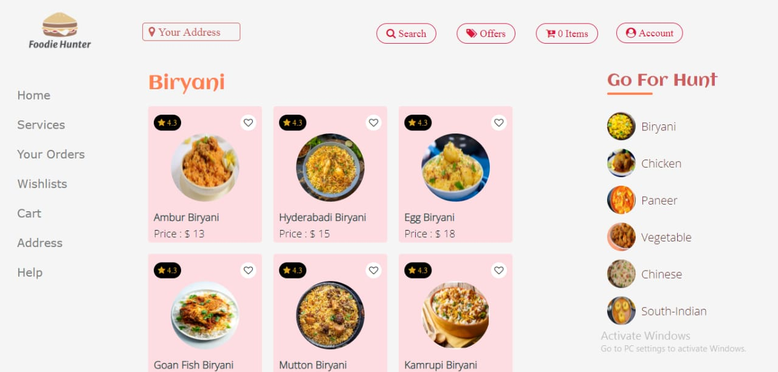

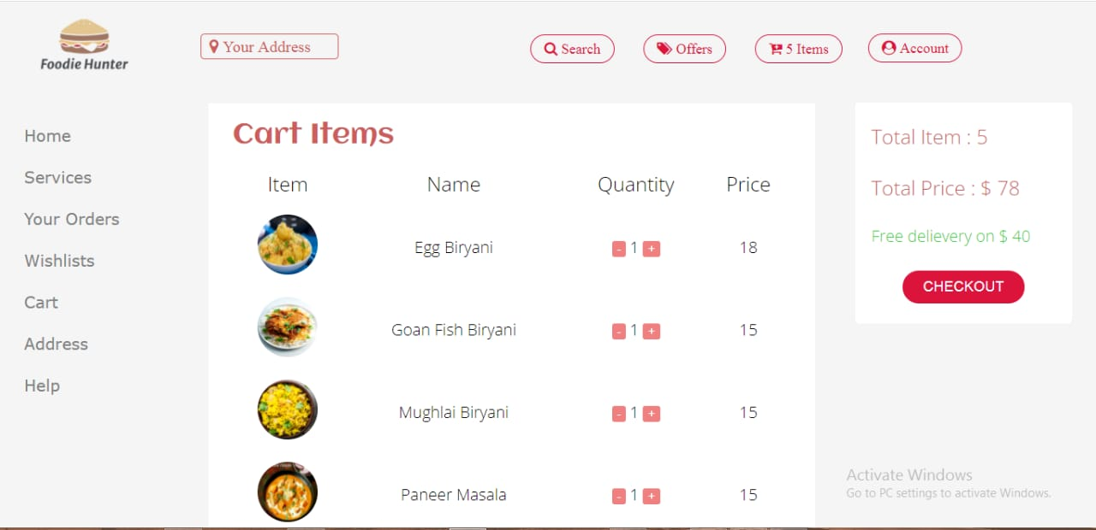

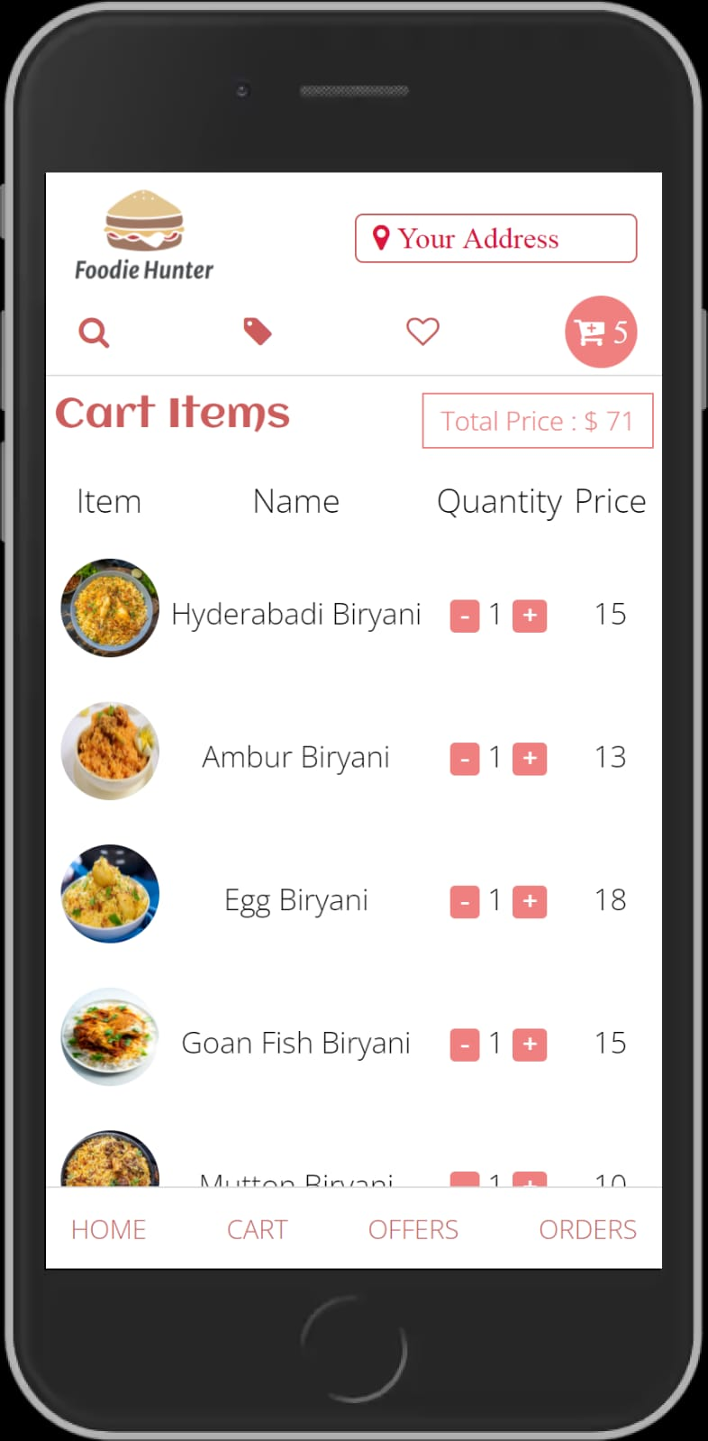

**Conclusion & Future Scope**

In conclusion, food online delivery is a convenient and efficient way to get your favorite meals delivered straight to your doorstep. With just a few clicks on a website or app, you can browse menus, place an order, and track the status of your delivery in real time. This service is especially convenient for those who are short on time, or who simply want the convenience of having their favorite meals delivered to their doorstep. It is also a great option for those who may have mobility issues, or who prefer to stay home and relax.

Looking to the future, it is likely that the popularity of food online delivery will continue to grow. As more and more people become accustomed to the convenience of having their meals delivered, it is likely that the demand for this service will continue to increase. In addition, as technology continues to advance, it is possible that we will see even more innovations in the food delivery space. With the help of artificial intelligence, for example, it may be possible to streamline the ordering process even further, making it even more convenient for customers to get the meals they want, when they want them.